## 

# ATHLONE INSTITUTE OF TECHNOLOGY

**SUMMER** **EXAMINATIONS** **2020/2021**

**MODULE:** SFTW09057-29497 - Object Oriented Programming II

### PROGRAMME(S):

|  |  |
| --- | --- |
| AL_KSAIP_9 | Postgraduate Diploma in Science in Software Design with Artificial Intelligence |
| AL_KSAIM_9 | Master of Science in Software Design with Artificial Intelligence |
| AL_KPGSD_9 | Special Purpose Award - Postgraduate Certificate in Software Design |
| AL_KCYBR_9 | Postgraduate Diploma in Science in Software Design with Cyber Security |
| AL_KCYBM_9 | Master of Science in Software Design with Cyber Security |
| AL_KCNCP_9 | Postgraduate Diploma in Science in Software Design with Cloud Native Computing |
| AL_KCNCM_9 | Master of Science in Software Design with Cloud Native Computing |
| AL_KAIMF_9 | Master of Science in Software Design with Artificial Intelligence |
|  |  |

**YEAR OF STUDY:** 1

**EXAMINER(S):**

|  |  |
| --- | --- |
| Dr. Sean Kennedy | (Internal) |
| Dr. Thiago Rodrigues | (Internal) |
| Dr. Adriana Chis | (External) |
| Dr. Kevin Curran | (External) |
| Dr. Christina Thorpe | (External) |

**TIME ALLOWED:** 2 Hours

**WEIGHT:** 25%

**INSTRUCTIONS: Answer all questions.**

**MAKE SURE YOU HAVE RECEIVED THE CORRECT EXAM PAPER. PLEASE DO NOT TURN OVER THIS PAGE UNTIL YOU ARE INSTRUCTED TO DO SO.**

The use of programmable or text storing calculators is expressly forbidden.

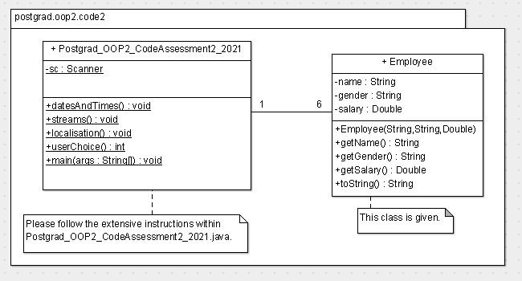

This Java assessment is based on the above UML diagram. You are provided with a template java file **Postgrad_OOP2_CodeAssessment2_2021.java**. Follow the instructions in that file.

In addition, you are given 3 properties files, namely CountingBundle.properties, CountingBundle _de_DE.properties and CountingBundle _fr_FR.properties. Insert the properties files into the same directory as the java file. Insert your name at the top of the Java file. The detailed instructions are in the Postgrad_OOP2_CodeAssessment2_2021.java file. When finished, upload Postgrad_OOP2_CodeAssessment2_2021.java to Moodle.

**Marking Scheme**

